Supplementary Material

Major exclusion criteria
Major exclusion criteria included: a diagnosis of vascular dementia, dementia following multiple strokes or any synucleinopathy/Lewy body disorder, including dementia with Lewy bodies and Parkinson's disease with or without dementia; a current diagnosis of moderate to severe obstructive sleep apnea (OSA) or central sleep apnea, or current use of continuous positive airways pressure even if mild severity of OSA; restless legs syndrome; periodic limb movement disorder (with awakenings); narcolepsy; current symptoms or history during the past year of rapid eye movement behavior disorder or sleep-related violent behavior. Subjects were also excluded if they had a clinically significant movement disorder that would affect the differentiation of sleep and wake by the actigraphy analytic algorithm; probable major depression, as evidenced by score > 10 on the Cornell Scale for Depression in Dementia at screening, or suicidal ideation; evidence of history of clinically significant disease or psychiatric condition that in the opinion of the investigator(s) could affect the subject's safety or interfere with the study assessments; and if they used any modality of treatment for ISWRD between screening and randomization based on approaches related to circadian rhythms, including phototherapy (light therapy), melatonin and melatonin agonists.

Table S1. Cognitive assessments at baseline and day 29
 | PBO  (n = 12) | Lemborexant
 |  | 2.5 mg  (n = 12) | 5 mg  (n = 13) | 10 mg  (n = 13) | 15 mg  (n = 12)
Mean (SD) MMSE total score
Baseline | 19.8 (5.0) | 22.2 (4.2) | 22.1 (2.8) | 19.8 (4.4) | 21.0 (4.2)
Day 29 | 21.1 (6.2) | 23.5 (5.0) | 22.6 (2.7) | 20.3 (4.6) | 20.1 (5.8)
Change from baseline at day 29* | 1.3 (2.5) | 1.3 (2.1) | 0.5 (1.9) | 0.5 (3.1) | −0.9 (3.7)
LS mean estimate (95% CI)* | 1.9  (−0.8, 4.5) | 2.0  (−0.6, 4.6) | 1.0  (−1.2, 3.2) | 1.2  (−1.4, 3.7) | −0.3  (−2.9, 2.3)
LS mean difference vs PBO (95% CI)* |  | 0.1  (−2.3, 2.4) | −0.9  (−3.2, 1.5) | −0.7  (−3.0, 1.5) | −2.1  (−4.4, 0.1)
p value* |  | 0.945 | 0.459 | 0.511 | 0.064
Mean (SD) ADAS-Cog score
Baseline | 29.4 (17.4) | 29.9 (11.7) | 27.0 (8.8) | 30.7 (15.5) | 28.9 (14.5)
Day 29 | 30.3 (18.5) | 26.2 (12.6) | 28.0 (9.9) | 29.7 (12.4) | 28.8 (13.9)
Change from baseline at day 29* | 0.8 (3.8) | −3.7 (5.0) | 1.0 (3.9) | −0.9 (5.4) | 2.6 (4.5)
LS mean estimate (95% CI)* | −0.3  (−4.6, 4.0) | −4.8  (−9.2, −0.4) | 0.0  (−3.7, 3.7) | −1.9  (−6.1, 2.3) | 1.2  (−3.3, 5.6)
LS mean difference vs PBO (95% CI)* |  | −4.5  (−8.3, −0.7) | 0.3  (−3.5, 4.2) | −1.6  (−5.3, 2.1) | 1.5  (−2.4, 5.5)
p value* |  | 0.023 | 0.859 | 0.390 | 0.445
*Based on an analysis of covariance model adjusted for baseline value and country. ADAS-Cog, Alzheimer’s Disease Assessment Scale-Cognitive Subscale; CI, confidence interval; LS, least squares; MMSE, Mini-Mental State Examination; PBO, placebo; SD, standard deviation.
Figure S1. Partial correlation network analysis of percentage change from baseline for efficacy variables at week 4 for placebo and LEM5.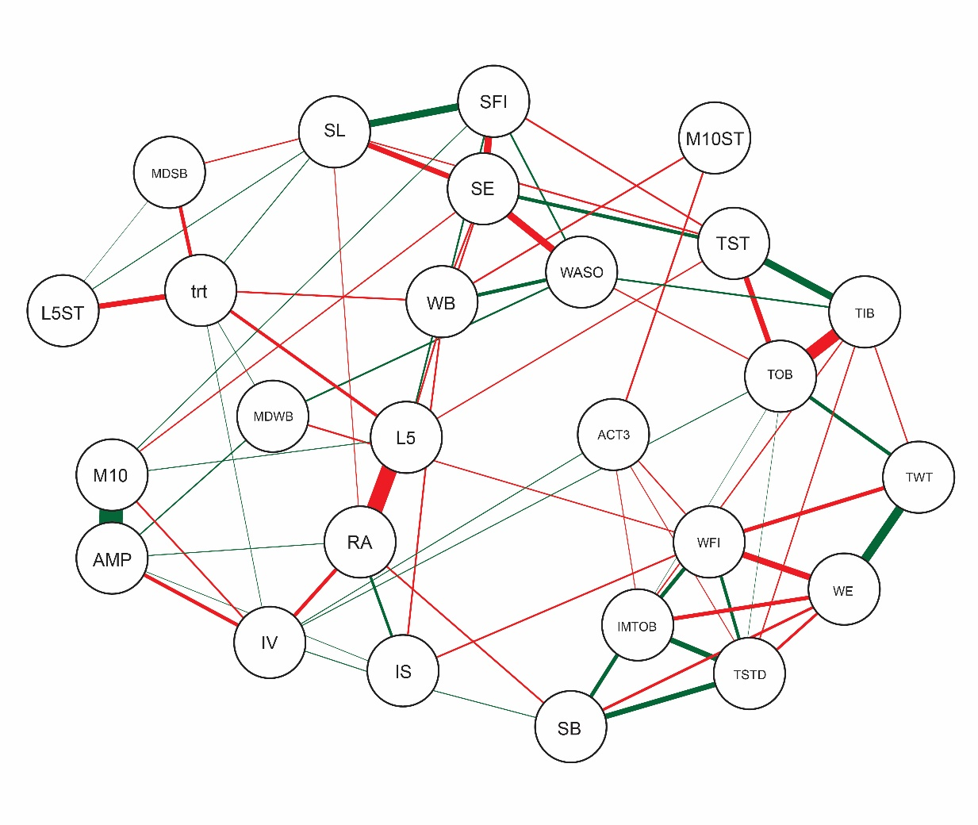
The presence of a line indicates existence of a partial correlation between the variables. A green line represents a positive correlation and a red line represents an inverse correlation. Line thickness represents the strength of the correlation between the variables. ACT3, average activity in first 3 hours of the morning; AMP, average amplitude; HH, hours on 24-hour clock; IMTOB, average immobile minutes out of bed; IS, average interdaily stability; IV, average intradaily variability; L5, average least active 5-hour period per 24-hour period; L5ST, average start hour of L5 (HH); M10, average most active 10-hour period per 24-hour period; M10ST, average start hour of M10 (HH); MDSB, mean duration of sleep bouts (minutes); MDWB, mean duration of wake bouts (minutes); RA, average relative amplitude of the rest-activity rhythm; SB, average number of sleep bouts; SE, average sleep efficiency (%); SFI, average sleep fragmentation index (%); SL, average sleep latency (minutes); TIB, average time in bed (minutes); TOB, average time out of bed (minutes); trt, treatment; TST, average total sleep time (minutes); TSTD, average total sleep time day (minutes); TWT, average total wake time (minutes); WASO, average wake after sleep onset (minutes); WB, average number of wake bouts; WE, average wake efficiency (%); WFI, average wake fragmentation index (%).

Figure S2. Box plot showing percentage change from baseline to week 4 in mean duration of sleep bouts during the daytime by treatment arm. The horizontal lines within the boxes represent median values and the boxes represent the 25th and 75th percentiles.
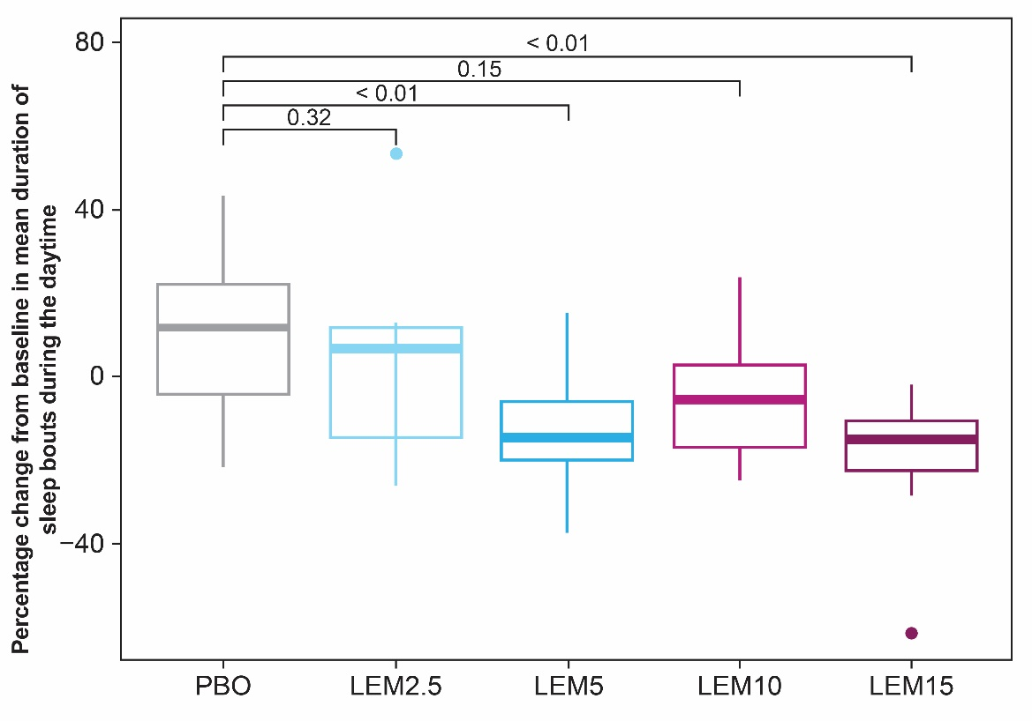
Numbers shown at the top of the figure are p values. P values were generated using Wilcoxon test. LEM2.5, lemborexant 2.5 mg; LEM5, lemborexant 5 mg; LEM10, lemborexant 10 mg; LEM15, lemborexant 15 mg; PBO, placebo.

Figure S3. Responder analyses at 4 weeks of treatment for main efficacy variables identified in the network analysis. (a) Subjects with > 5% decreases from baseline for both L5 and mean duration of sleep bouts during the daytime. (b) Subjects with change from baseline > 0% for mean RA and IS, and < 0% for mean duration of sleep bouts during the daytime.
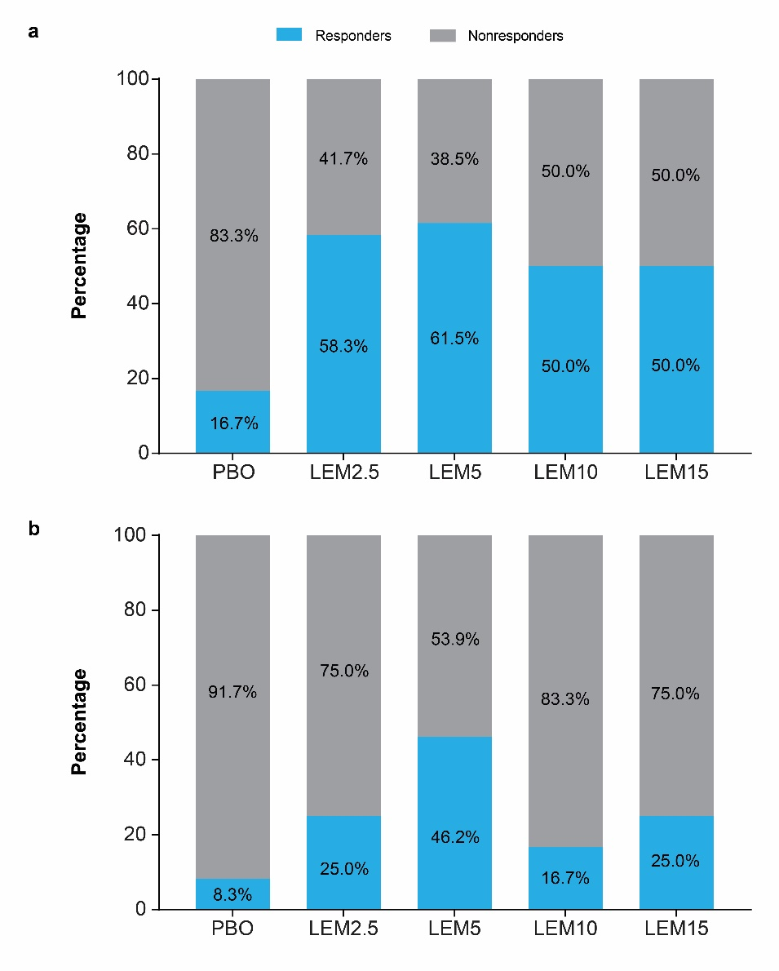
IS, interdaily stability; L5, least active 5 hours of the day; LEM2.5, lemborexant 2.5 mg; LEM5, lemborexant 5 mg; LEM10, lemborexant 10 mg; LEM15, lemborexant 15 mg; PBO, placebo; RA, relative amplitude.

