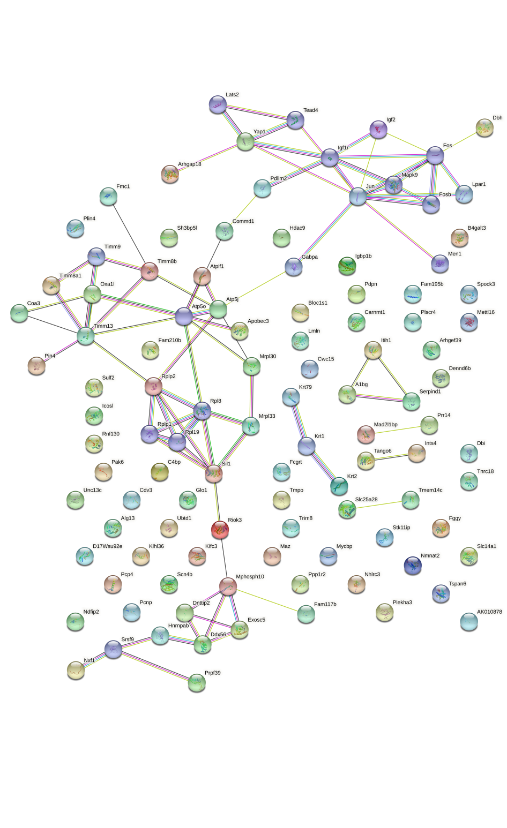
Fig. 1 The protein interaction of IVIG-A vs Ctrl group.
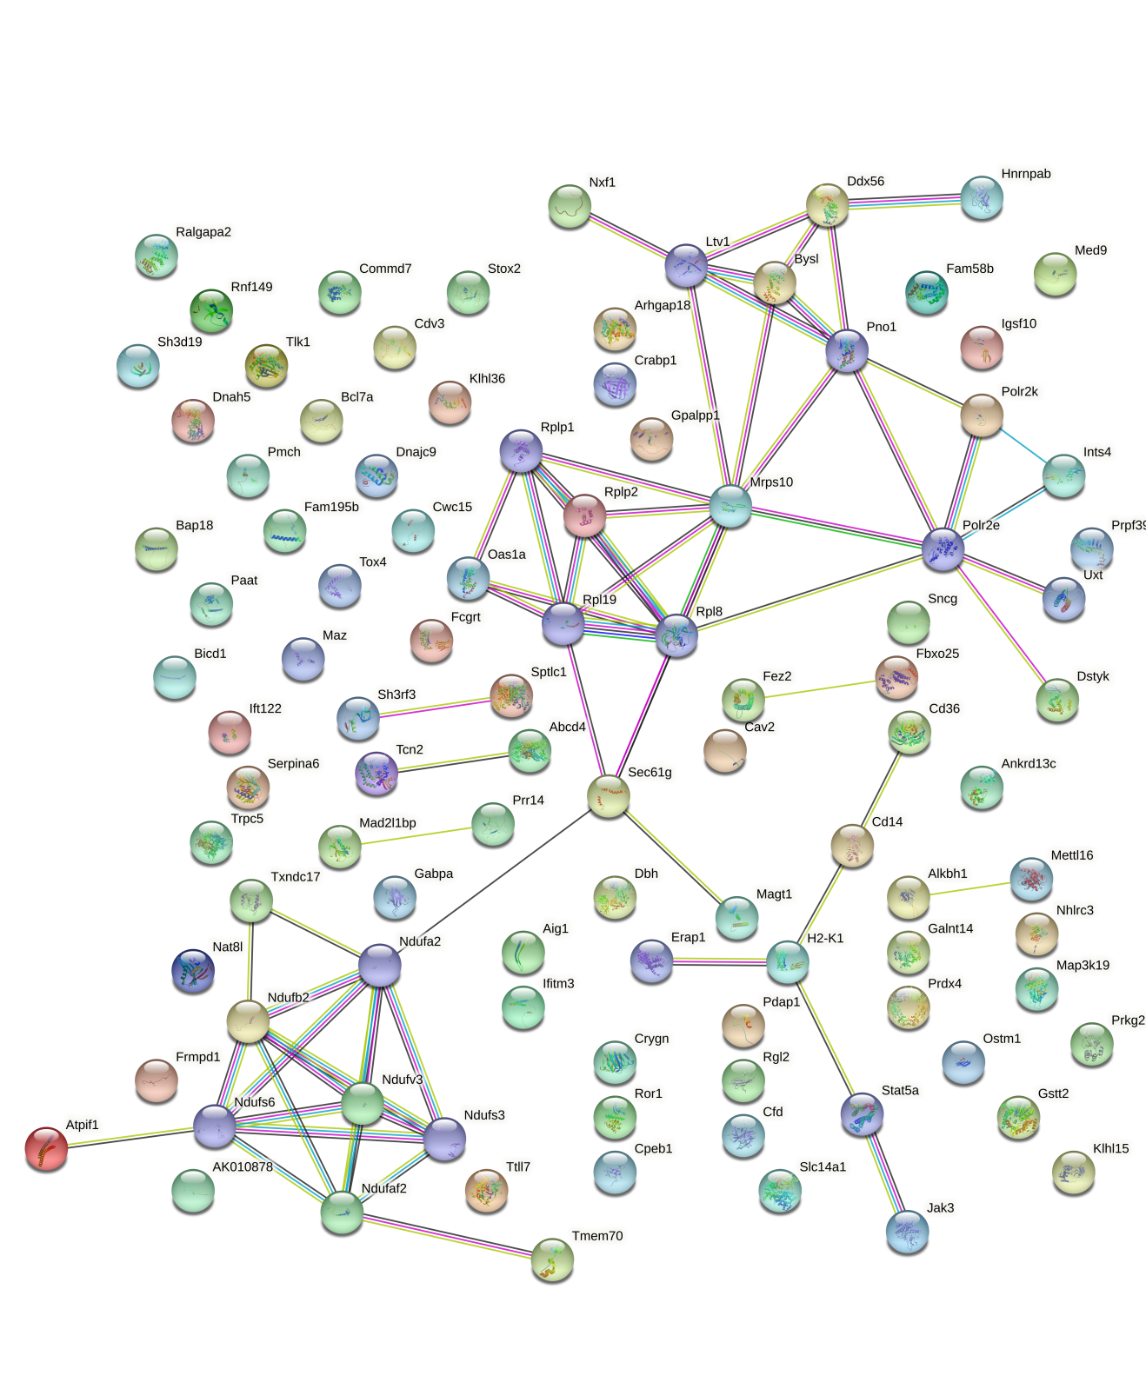
Fig. 2 The protein interaction of IVIG-B vs Ctrl group.

