**Supplement Table I** N1 latencies (ms, mean ± S.D.) and amplitudes (μv, mean ± S.D.) under Happiness, Neutral, and Sadness in healthy volunteers (Controls, n = 51), patients with Mild Cognitive Impairment (MCI, n = 52), and Alzheimer’s disease (AD, n = 47)

|  |  |  |  |  |  |  |  |
| --- | --- | --- | --- | --- | --- | --- | --- |
|  |  | N1 Latency | | | N1 amplitude | | |
|  |  | Controls | MCI | AD | Controls | MCI | AD |
| Neutral |  |  |  |  |  |  |  |
|  | F3 | 131.66 ± 34.98 | 144.25 ± 38.10 | 136.10 ± 38.80 | -2.57 ± 2.20 | -3.13 ± 2.24 | -2.78 ± 2.42 |
|  | Fz | 129.11 ± 34.71 | 144.17 ± 38.25 | 129.50 ± 32.89 | -2.60 ± 2.21 | -3.05 ± 2.12 | -2.73 ± 2.46 |
|  | F4 | 125.36 ± 36.30 | 141.58 ± 36.80 | 133.30 ± 36.59 | -2.34 ± 2.18 | -2.89 ± 1.91 | -2.30 ± 2.09 |
|  | C3 | 135.66 ± 41.08 | 145.50 ± 39.69 | 137.70 ± 39.36 | -2.95 ± 2.04 | -3.19 ± 2.71 | -2.12 ± 2.31 |
|  | Cz | 127.57 ± 35.68 | 142.08 ± 39.11 | 130.30 ± 34.52 | -2.83 ± 2.52 | -3.08 ± 2.87 | -2.13 ± 2.38 |
|  | C4 | 127.15 ± 36.85 | 142.42 ± 39.08 | 130.10 ± 37.01 | -2.32 ± 2.20 | -2.57 ± 2.38 | -1.69 ± 2.18 |
|  | P3 | 188.77 ± 30.26 | 179.92 ± 30.58 | 183.20 ± 32.84 | -3.67 ± 3.08 | -3.46 ± 4.30 | -2.60 ± 3.02 |
|  | Pz | 187.66 ± 33.61 | 179.67 ± 31.36 | 178.80 ± 35.54 | -2.43 ± 3.03 | -2.42 ± 3.76 | -1.26 ± 3.00 |
|  | P4 | 185.45 ± 32.46 | 176.33 ± 30.33 | 185.70 ± 33.71 | -2.15 ± 3.03 | -2.84 ± 3.61 | -1.66 ± 3.45 |
| Happiness |  |  |  |  |  |  |  |
|  | F3 | 128.43 ± 30.84 | 134.13 ± 35.74 | 135.24 ± 38.05 | -3.23 ± 2.38 | -3.40 ± 2.49 | -3.42 ± 2.18 |
|  | Fz | 124.43 ± 27.92 | 132.00 ± 37.89 | 136.19 ± 38.16 | -3.23 ± 2.68 | -3.40 ± 2.46 | -3.21 ± 2.22 |
|  | F4 | 123.32 ± 30.65 | 132.77 ± 38.33 | 139.43 ± 39.24 | -3.08 ± 2.42 | -3.41 ± 2.16 | -3.10 ± 1.96 |
|  | C3 | 130.89 ± 33.86 | 136.17 ± 42.90 | 135.24 ± 40.38 | -3.42 ± 2.43 | -3.24 ± 2.63 | -3.22 ± 2.38 |
|  | Cz | 121.45 ± 29.62 | 126.64 ± 39.76 | 130.67 ± 36.54 | -3.61 ± 2.69 | -3.19 ± 2.81 | -2.85 ± 2.39 |
|  | C4 | 125.62 ± 34.23 | 130.30 ± 39.75 | 138.48 ± 41.32 | -2.90 ± 2.46 | -2.86 ± 2.33 | -2.22 ± 2.06 |
|  | P3 | 179.49 ± 29.81 | 184.51 ± 29.74 | 181.43 ± 33.45 | -3.85 ± 2.88 | -2.87 ± 3.68 | -2.42 ± 2.95 |
|  | Pz | 178.04 ± 33.18 | 180.77 ± 33.53 | 178.76 ± 37.91 | -2.47 ± 2.95 | -2.07 ± 3.12 | -1.75 ± 3.04 |
|  | P4 | 177.79 ± 31.29 | 176.00 ± 33.20 | 181.43 ± 32.37 | -2.25 ± 2.91 | -2.35 ± 3.27 | -1.85 ± 3.00 |
| Sadness |  |  |  |  |  |  |  |
|  | F3 | 126.33 ± 30.63 | 135.57 ± 39.45 | 136.95 ± 35.91 | -3.23 ± 1.61 | -3.35 ± 2.58 | -3.00 ± 2.86 |
|  | Fz | 124.17 ± 27.63 | 132.17 ± 39.14 | 138.38 ± 36.10 | -3.25 ± 1.92 | -3.04 ± 2.48 | -2.87 ± 2.75 |
|  | F4 | 131.25 ± 29.61 | 134.21 ± 36.50 | 140.86 ± 36.60 | -2.92 ± 1.86 | -2.94 ± 2.34 | -2.38 ± 2.44 |
|  | C3 | 127.67 ± 35.77 | 137.02 ± 41.74 | 139.33 ± 38.28 | -3.38 ± 1.92 | -3.22 ± 2.48 | -2.51 ± 2.34 |
|  | Cz | 129.67 ± 34.38 | 130.55 ± 40.09 | 135.33 ± 34.87 | -3.58 ± 2.28 | -2.75 ± 2.60 | -2.36 ± 2.31 |
|  | C4 | 134.58 ± 36.54 | 133.87 ± 38.40 | 133.33 ± 32.14 | -2.74 ± 1.94 | -1.94 ± 2.48 | -1.77 ± 2.16 |
|  | P3 | 187.67 ± 30.33 | 184.17 ± 31.23 | 188.48 ± 33.29 | -3.85 ± 2.86 | -2.25 ± 2.99 | -1.52 ± 2.62 |
|  | Pz | 188.25 ± 32.35 | 185.28 ± 35.82 | 191.05 ± 32.28 | -2.35 ± 2.99 | -1.13 ± 2.93 | -0.83 ± 2.95 |
|  | P4 | 191.08 ± 29.40 | 180.68 ± 33.99 | 186.67 ± 35.54 | -2.05 ± 2.88 | -1.27 ± 3.66 | -0.98 ± 2.70 |

**Supplement Table II** P2 latencies (ms, mean ± S.D.) and amplitudes (μv, mean ± S.D.) under Happiness, Neutral, and Sadness in healthy volunteers (Controls, n = 51), patients with Mild Cognitive Impairment (MCI, n = 52), and Alzheimer’s disease (AD, n = 47)

|  |  |  |  |  |  |  |  |
| --- | --- | --- | --- | --- | --- | --- | --- |
|  |  | P2 Latency | | | P2 amplitude | | |
|  |  | Controls | MCI | AD | Controls | MCI | AD |
| Neutral |  |  |  |  |  |  |  |
|  | F3 | 232.60 ± 48.09 | 231.83 ± 36.13 | 231.70 ± 46.06 | 4.67 ± 5.43 | 4.06 ± 3.66 | 3.21 ± 3.57 |
|  | Fz | 231.91 ± 45.86 | 228.58 ± 33.55 | 235.90 ± 46.33 | 5.67 ± 5.35 | 4.81 ± 3.81 | 3.71 ± 3.85 |
|  | F4 | 232.94 ± 48.45 | 227.33 ± 35.59 | 236.80 ± 48.39 | 5.26 ± 4.92 | 4.63 ± 3.49 | 3.70 ± 3.63 |
|  | C3 | 230.55 ± 52.19 | 229.75 ± 39.25 | 231.80 ± 47.93 | 3.73 ± 5.27 | 3.54 ± 3.92 | 3.18 ± 3.32 |
|  | Cz | 231.23 ± 51.63 | 226.67 ± 36.28 | 241.00 ± 48.39 | 5.07 ± 6.07 | 4.86 ± 4.21 | 4.39 ± 4.01 |
|  | C4 | 237.19 ± 49.41 | 228.08 ± 36.66 | 235.40 ± 45.23 | 5.31 ± 5.51 | 4.76 ± 3.62 | 4.23 ± 3.72 |
|  | P3 | 268.60 ± 39.33 | 256.33 ± 32.27 | 264.70 ± 38.64 | 3.07 ± 5.62 | 3.65 ± 4.83 | 2.66 ± 3.83 |
|  | Pz | 264.17 ± 42.45 | 254.25 ± 32.78 | 260.90 ± 38.64 | 3.78 ± 5.27 | 3.93 ± 4.23 | 3.94 ± 3.18 |
|  | P4 | 264.00 ± 41.33 | 254.92 ± 33.25 | 263.20 ± 40.58 | 4.43 ± 5.46 | 3.83 ± 4.02 | 3.70 ± 3.93 |
| Happiness |  |  |  |  |  |  |  |
|  | F3 | 227.15 ± 39.63 | 234.30 ± 38.12 | 244.00 ± 40.92 | 5.04 ± 4.01 | 3.55 ± 3.26 | 3.96 ± 3.45 |
|  | Fz | 227.23 ± 37.30 | 235.49 ± 37.08 | 240.19 ± 39.22 | 5.80 ± 4.44 | 4.57 ± 3.60 | 4.15 ± 3.36 |
|  | F4 | 225.96 ± 37.91 | 235.66 ± 38.04 | 241.05 ± 37.95 | 5.35 ± 4.03 | 4.39 ± 3.47 | 3.68 ± 3.09 |
|  | C3 | 227.06 ± 40.70 | 232.43 ± 39.83 | 246.19 ± 41.22 | 3.99 ± 3.95 | 3.65 ± 3.88 | 3.58 ± 3.51 |
|  | Cz | 227.66 ± 38.56 | 228.77 ± 42.42 | 240.38 ± 40.75 | 5.32 ± 4.53 | 4.55 ± 3.98 | 4.52 ± 3.63 |
|  | C4 | 229.79 ± 38.76 | 235.32 ± 43.77 | 238.48 ± 44.66 | 5.23 ± 4.15 | 4.68 ± 3.48 | 4.10 ± 3.20 |
|  | P3 | 254.30 ± 36.02 | 259.91 ± 33.37 | 259.05 ± 33.29 | 2.28 ± 4.16 | 3.29 ± 3.85 | 3.06 ± 3.73 |
|  | Pz | 249.96 ± 37.07 | 260.17 ± 35.02 | 257.90 ± 35.93 | 3.27 ± 4.28 | 3.34 ± 3.67 | 3.31 ± 3.64 |
|  | P4 | 255.40 ± 34.25 | 258.81 ± 33.88 | 257.62 ± 34.65 | 3.66 ± 3.93 | 3.79 ± 3.53 | 3.07 ± 3.92 |
| Sadness |  |  |  |  |  |  |  |
|  | F3 | 225.83 ± 45.62 | 233.19 ± 38.06 | 235.05 ± 45.10 | 3.98 ± 4.88 | 3.66 ± 4.42 | 3.79 ± 3.49 |
|  | Fz | 225.92 ± 43.56 | 234.30 ± 38.62 | 238.76 ± 46.64 | 4.85 ± 4.90 | 4.52 ± 4.70 | 3.74 ± 3.66 |
|  | F4 | 227.25 ± 40.66 | 236.09 ± 38.10 | 238.67 ± 50.37 | 4.72 ± 4.31 | 4.37 ± 4.23 | 3.71 ± 3.55 |
|  | C3 | 224.50 ± 44.77 | 231.66 ± 40.14 | 236.38 ± 50.11 | 3.30 ± 4.51 | 3.27 ± 4.29 | 3.52 ± 3.15 |
|  | Cz | 218.00 ± 43.19 | 231.06 ± 39.21 | 236.29 ± 49.87 | 4.61 ± 5.17 | 4.56 ± 4.87 | 4.42 ± 3.84 |
|  | C4 | 221.08 ± 43.98 | 232.26 ± 39.21 | 235.05 ± 48.80 | 4.72 ± 4.31 | 5.05 ± 4.61 | 4.11 ± 3.57 |
|  | P3 | 269.75 ± 29.30 | 256.17 ± 38.10 | 264.19 ± 31.27 | 2.39 ± 4.96 | 3.40 ± 3.45 | 3.38 ± 3.94 |
|  | Pz | 268.50 ± 28.77 | 257.02 ± 39.32 | 263.81 ± 35.54 | 2.83 ± 4.90 | 3.69 ± 3.56 | 3.94 ± 3.81 |
|  | P4 | 269.33 ± 29.15 | 254.47 ± 37.26 | 268.29 ± 36.10 | 3.72 ± 4.33 | 4.24 ± 3.92 | 3.95 ± 3.45 |

**Supplement Table III** N2 amplitudes (μv, mean ± S.D.) under Happiness, Neutral, and Sadness in healthy volunteers (Controls, n = 51), patients with Mild Cognitive Impairment (MCI, n = 52), and Alzheimer’s disease (AD, n = 47)

|  |  |  |  |
| --- | --- | --- | --- |
|  | Controls | MCI | AD |
| Neutral |  |  |  |
|  | 0.60 ± 6.37 | -0.94 ± 3.62 | -1.13 ± 4.13 |
|  | 1.07 ± 6.95 | -0.76 ± 4.13 | -0.74 ± 4.42 |
|  | 1.16 ± 6.05 | -0.26 ± 3.48 | -0.26 ± 4.15 |
|  | -0.50 ± 6.81 | -1.45 ± 4.38 | -1.33 ± 4.40 |
|  | 0.39 ± 7.78 | -0.38 ± 4.58 | -0.28 ± 5.06 |
|  | 1.51 ± 6.57 | 0.42 ± 3.72 | 0.25 ± 4.43 |
|  | 1.02 ± 6.70 | 1.31 ± 4.97 | -0.29 ± 4.62 |
|  | 1.95 ± 6.35 | 1.87 ± 4.97 | 0.87 ± 4.66 |
|  | 2.60 ± 6.13 | 2.22 ± 4.47 | 0.74 ± 4.26 |
| Happiness |  |  |  |
|  | 0.39 ± 5.41 | -1.74 ± 4.01 | -1.50 ± 3.85 |
|  | 0.75 ± 5.85 | -1.11 ± 4.79 | -1.39 ± 3.99 |
|  | 1.11 ± 4.98 | -0.84 ± 4.01 | -1.31 ± 3.61 |
|  | -0.57 ± 5.62 | -1.90 ± 4.35 | -2.05 ± 4.01 |
|  | 0.35 ± 6.50 | -1.08 ± 5.02 | -1.13 ± 4.25 |
|  | 1.37 ± 5.45 | -0.32 ± 4.02 | -0.71 ± 3.72 |
|  | 0.32 ± 5.04 | 0.77 ± 3.82 | -0.97 ± 3.87 |
|  | 1.06 ± 4.98 | 0.86 ± 3.84 | -0.21 ± 4.08 |
|  | 1.79 ± 4.41 | 1.51 ± 3.68 | -0.22 ± 3.87 |
| Sadness |  |  |  |
|  | -0.18 ± 5.72 | -1.56 ± 4.52 | -1.77 ± 3.70 |
|  | 0.16 ± 6.41 | -1.06 ± 5.08 | -1.63 ± 4.12 |
|  | 0.50 ± 5.65 | -0.73 ± 4.10 | -1.20 ± 3.83 |
|  | -1.09 ± 6.18 | -2.23 ± 4.24 | -1.86 ± 3.94 |
|  | -0.47 ± 7.14 | -0.91 ± 5.10 | -0.95 ± 4.72 |
|  | 0.72 ± 6.08 | 0.08 ± 4.23 | -0.54 ± 4.08 |
|  | 0.47 ± 5.56 | 0.31 ± 3.47 | -0.02 ± 4.48 |
|  | 1.06 ± 5.65 | 0.99 ± 3.49 | 0.71 ± 4.28 |
|  | 2.06 ± 5.15 | 1.63 ± 3.59 | 1.10 ± 3.78 |

**Supplement Figure I** Under Neutral, averages of ERPs elicited by target stimuli at nine electrodes in healthy volunteers (dashed line; n = 51), patients with Mild Cognitive Impairment (thin line; n = 52) and Alzheimer’s disease (thick line; n = 47)

**Supplement Figure II** Under Sadness, averages of ERPs elicited by target stimuli at nine electrodes in healthy volunteers (dashed line; n = 51), patients with Mild Cognitive Impairment (thin line; n = 52) and Alzheimer’s disease (thick line; n = 47)

图表

**A**

**B**

**Supplement Figure III** Under Neutral **(A)** and Sadness **(B),** averaged scalp topographies of P3 component (time window: 330 ~ 580 ms) to the target stimuli in healthy volunteers (Controls, n = 51), patients with Mild Cognitive Impairment (MCI, n = 52) and Alzheimer’s disease (AD, n = 47)

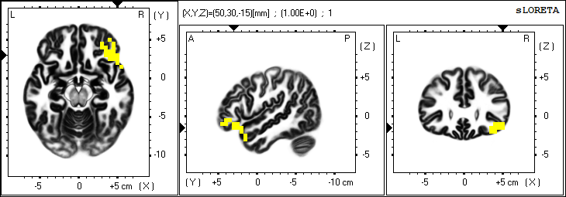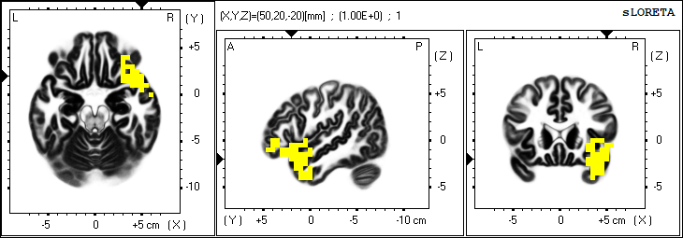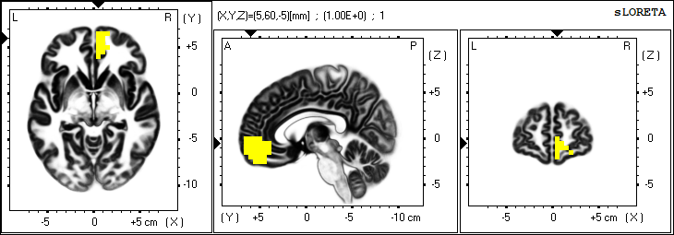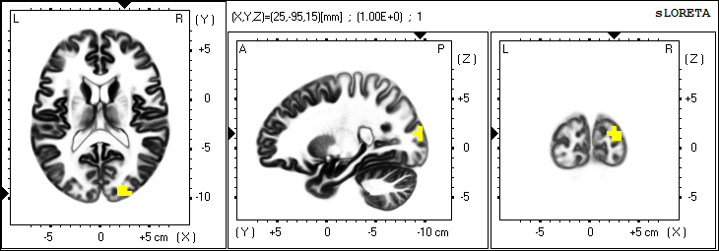

**A**

**B**

**C**

**D**

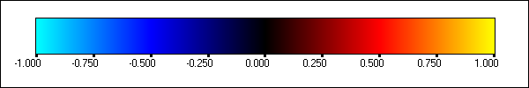

**Supplement Figure IV** sLORETA source localization focused on the MNI coordinate in **(A)** N2 component (time window: 200 ~ 400 ms) to the target stimuli under Neutral with the maximum difference between patients with Alzheimer’s disease and healthy volunteers at right Superior Temporal Gyrus(Temporal Lobe, MNI XYZ: 50/20/-20); **(B)** N2 component under Happiness with the maximum difference between patients with Mild Cognitive Impairment and healthy volunteers at right Inferior Frontal Gyrus(Frontal Lobe, MNI XYZ: 50/30/-15); **(C)** N2 component under Sadness with the maximum difference between patients with Alzheimer’s disease and Mild Cognitive Impairment at right Superior Frontal Gyrus(Frontal Lobe, MNI XYZ: 5/60/-5); **(D)** P3 component under Sadness with the maximum difference between patients with Alzheimer’s disease and Mild Cognitive Impairment at right Middle Occipital Gyrus(Occipital Lobe, MNI XYZ: 25/-95/15)