Supplemental Table 1. Baseline demographic and disease characteristics differences between the Japanese subgroup and the overall population

 | EMERGE |  |  | ENGAGE
Japanese | Placebo  (n=43) | Low dose  (n=38) | High dose  (n=40) | Placebo  (n=33) | Low dose  (n=29) | High dose  (n=38)
CDR-SB, mean ± SD | 2.15±0.842 | 2.34±1.053 | 2.53±1.224 | 2.21±0.829 | 2.34±1.053 | 1.83±1.028
Weight, mean ± SD, kg | 54.98  ±10.183 | 55.56  ±9.859 | 55.67  ±8.723 | 53.26  ±9.885 | 51.96  ±10.356 | 55.00  ±7.856
ApoE ε4, n (%)
Carriers | 23 (53.5) | 24 (63.2) | 25 (62.5) | 21 (63.6) | 22 (75.9) | 24 (63.2)
Noncarriers | 20 (46.5) | 14 (36.8) | 15 (37.5) | 12 (36.4) | 7 (24.1) | 14 (36.8)
 | EMERGE |  |  | ENGAGE
Overall | Placebo  (n=548) | Low dose  (n=543) | High dose  (n=547) | Placebo  (n=545) | Low dose  (n=547) | High dose  (n=555)
CDR-SB, mean ± SD* | 2.47±1.00 | 2.46±1.01 | 2.51±1.05 | 2.40±1.01 | 2.43±1.01 | 2.40±1.01
Weight, mean ± SD, kg† | 71.46  ±15.373 | 73.01  ±15.800 | 71.08  ±15.685 | 71.37  ±15.505 | 71.15  ±15.212 | 70.87  ±14.621
ApoE ε4, n (%)*
Carriers | 368 (67) | 362 (67) | 365 (67) | 376 (69) | 391 (71) | 378 (68)
Noncarriers | 178 (32) | 178 (33) | 181 (33) | 167 (31) | 156 (29) | 176 (32)

*These overall data were previously published (20).
†Unpublished observation.
ApoE, apolipoprotein E; SD, standard deviation.

Supplementary table 2. Cumulative dose (mg/kg) received, stratified by ApoE status, in the OTC population by March 20, 2019.
 | EMERGE
 | Low dose |  |  | High dose
 | ApoE Ꜫ4+  3 mg/kg  (n = 7) | ApoE Ꜫ4-  6 mg/kg  (n = 2) | Total  (n = 9) | ApoE Ꜫ4+  10 mg/kg  (n = 9) | ApoE Ꜫ4-  10 mg/kg  (n = 4) | Total  (n = 13)
Cumulative dose (mg/kg) received  Mean (SD) | 54.0  (2.65) | 44.0  (59.4) | 51.8 (21.58) | 115.3 (57.14) | 152.5 (15.00) | 126.8 (50.51)
Number of 10 mg/kg doses received  Mean (SD) | 0 | 0 | 0 | 9.3  (5.34) | 13.3  (1.50) | 10.5  (4.81)
 | ENGAGE
 | Low dose |  |  | High dose
 | ApoE Ꜫ4+  3 mg/kg  (n = 9) | ApoE Ꜫ4-  6 mg/kg  (n = 6) | Total  (n = 15) | ApoE Ꜫ4+  10 mg/kg  (n = 5) | ApoE Ꜫ4-  10 mg/kg  (n = 5) | Total  (n = 10)
Cumulative dose (mg/kg) received  Mean (SD) | 55.7  (1.00) | 74.8 (39.88) | 63.3 (25.75) | 119.8 (28.27) | 119.0 (65.04) | 119.4 (47.28)
Number of 10 mg/kg doses received  Mean (SD) | 0 | 0 | 0 | 8.6  (3.91) | 10.2  (5.85) | 9.4  (4.77)

Supplemental Table 3. Summary of ARIA incidents of the Japanese safety MRI population.
 | EMERGE |  |  | ENGAGE
 | Placebo  (n=43) | Low dose  (n=37) | High dose  (n=40) | Placebo  (n=33) | Low dose  (n=29) | High dose  (n=38)
ARIA-E, n (%) | 0 | 5 (13.5) | 8 (20.0) | 1 (3.0) | 2 (6.9) | 5 (13.2)
ApoE ε4 carriers, n/total (%) | 0 | 4/24 (16.7) | 5/25 (20.0) | 1/21 (4.8) | 1/22 (4.5) | 5/24 (20.8)
ApoE ε4 noncarriers, n/total (%) | 0 | 1/13 (7.7) | 3/15 (20.0) | 0 | 1/7 (14.3) | 0
ARIA-H microhemorrhage, n (%) | 1 (2.3) | 5 (13.5) | 8 (20.0) | 3 (9.1) | 2 (6.9) | 5 (13.2)
ARIA-H macrohemorrhage, n (%) | 0 | 0 | 0 | 1 (3.0) | 0 | 1 (2.6)
ARIA-H superficial siderosis, n (%) | 0 | 2 (5.4) | 2 (5.0) | 0 | 1 (3.4) | 3 (7.9)

Note: Any MRI events of brain microhemorrhage or localized superficial siderosis were reported as ARIA-H microhemorrhage or ARIA-H superficial siderosis, respectively. Only patients who were dosed and had ≥1 postbaseline safety MRI were included.
ApoE, apolipoprotein E, ARIA, amyloid related imaging abnormality; ARIA-E; ARIA-edema; ARIA-H, ARIA-microhemorrhages, macrohemorrhages, or superficial siderosis.

Supplemental Figure 1. Study enrollment and timing of key protocol amendments for the overall population and the Japanese subgroup
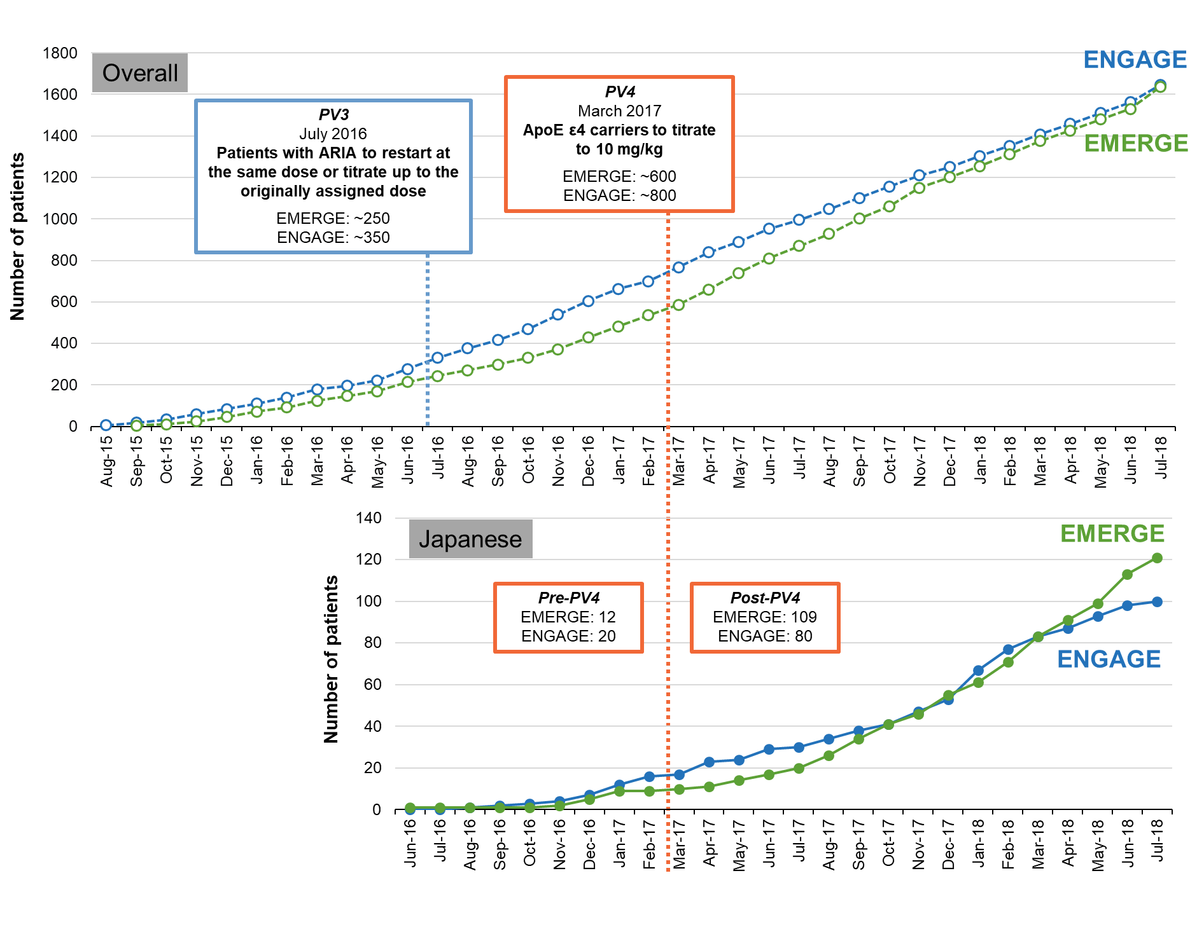
ApoE, apolipoprotein E; ARIA, amyloid related imaging abnormality; PV3, protocol version 3; PV4, protocol version 4.

Supplemental Figure 2. Observed serum PK profiles in the Japanese and non-Japanese populations
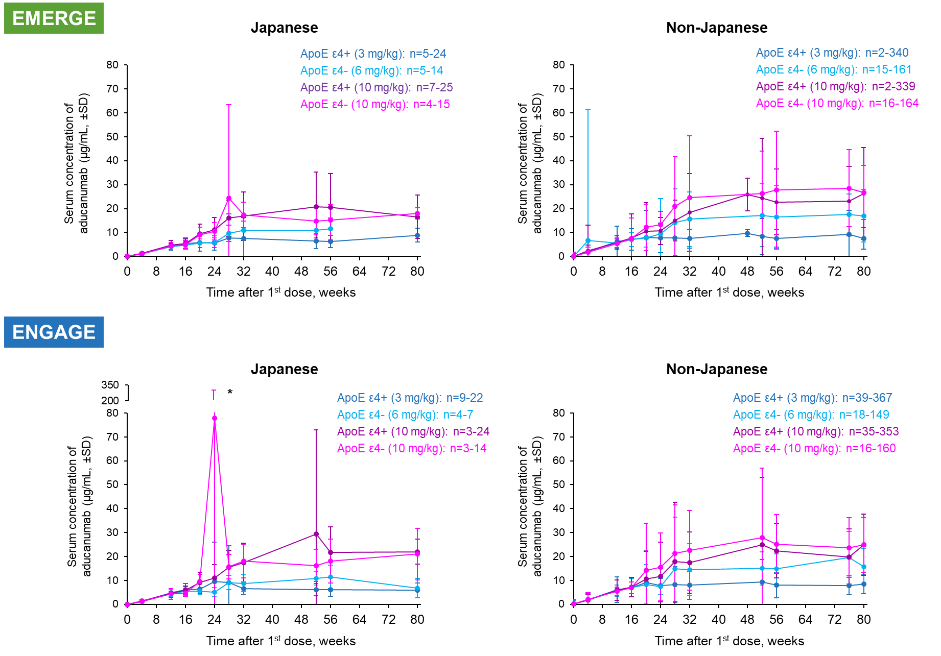
*One Japanese participant in ENGAGE had an increased serum aducanumab concentration value compared with the rest of the participants in the high-dose ApoE ε4– group (n=13) at Week 24

