**Table S1. Model selection process of the trajectory subgroups.** Firstly, we tested and determined the number of trajectories based on the log Bayes factor (2loge(B10)), which was calculated as 2×(BICcomplex-BICsimpler). We found that three trajectory curves provided the best fitting result. Secondly, we attempted various shapes of trajectory curves to discover the optimal shape for each trajectory based on the log Bayes factor, average posterior probability (above 0.7 indicated a better fit), minimum membership probability (above 5% indicated a better fit), and statistical measures (a significant p-value for each parameter implied a better fit). Finally, three trajectory curves, respectively linear, quadratic, and linear, were considered to provide the best fitting result. The table below presented the selection process.

|  |  |  |  |  |  |  |  |  |  |  |  |  |  |  |  |  |  |
| --- | --- | --- | --- | --- | --- | --- | --- | --- | --- | --- | --- | --- | --- | --- | --- | --- | --- |
| **Shapes of Subgroups** | | | | | | | **BIC** | **Average posterior probability** | | | | | | | | **Minimum membership probability (%)** | **2loge(B10)\*** |
| **1. To determine the number of trajectories** | | | | | | | | | | | | | | | | | |
| **Subgroup 1** | | | | | | |  | **Subgroup1** | | | | | | | |  |  |
| linear** | | | | | | | -58502.6 | 1.000 | | | | | | | | 20.56 | Null |
| **Subgroup 1** | | | **Subgroup 2** | | | |  | **Subgroup 1** | | | **Subgroup 2** | | | | |  |  |
| linear** | | | linear** | | | | -55758.1 | 0.933 | | | 0.988 | | | | | 11.99 | 5488.96 |
| **Subgroup 1** | | **Subgroup 2** | | | **Subgroup3** | |  | **Subgroup 1** | | **Subgroup 2** | | | **Subgroup3** | | |  |  |
| linear** | | linear** | | | linear** | | -55336.1 | 0.924 | | 0.822 | | | 0.960 | | | 5.95 | 844.08 |
| **Subgroup1** | **Subgroup2** | | | **Subgroup3** | | **Subgroup4** |  | **Subgroup1** | **Subgroup2** | | | **Subgroup3** | | | **Subgroup4** |  |  |
| linear** | linear** | | | linear** | | linear** | -55337.1 | 0.921 | 0.806 | | | 0.736 | | | 0.572 | 5.67 | -18.24 |
| **2. To determine the shape of each trajectory** | | | | | | | | | | | | | | | | | |
| **Subgroup 1** | | **Subgroup 2** | | | **Subgroup3** | |  | **Subgroup 1** | | **Subgroup 2** | | | | **Subgroup3** | | **Minimum membership probability (%)** | **2loge(B10)** |
| linear** | | linear** | | | linear** | | -55336.1 | 0.923 | | 0.822 | | | | 0.960 | | 5.95 | Null |
| linear** | | linear** | | | quadratic | | -55337.9 | 0.925 | | 0.821 | | | | 0.931 | | 5.97 | -3.6 |
| linear** | | linear** | | | cubic | | -55342.4 | 0.925 | | 0.821 | | | | 0.960 | | 5.97 | -9 |
| ***linear\*\**** | | ***quadratic\*\**** | | | ***linear\*\**** | | ***-55328.0*** | ***0.921*** | | ***0.808*** | | | | ***0.960*** | | ***6.63*** | ***28*** |
| linear** | | quadratic** | | | quadratic | | -55239.0 | 0.935 | | 0.838 | | | | 0.985 | | 4.57 | 178 |
| linear** | | quadratic** | | | cubic | | -55243.4 | 0.935 | | 0.838 | | | | 0.985 | | 4.57 | -8.8 |
| linear** | | cubic | | | linear** | | -55191.4 | 0.825 | | 0.933 | | | | 0.964 | | 6.05 | 104 |
| linear** | | cubic | | | quadratic | | -55243.4 | 0.935 | | 0.838 | | | | 0.985 | | 4.57 | -104 |
| linear** | | cubic | | | cubic | | -55247.9 | 0.935 | | 0.838 | | | | 0.985 | | 4.57 | -9 |
| quadratic | | linear** | | | linear** | | -55187.0 | 0.933 | | 0.825 | | | | 0.964 | | 6.05 | 121.8 |
| quadratic | | linear** | | | quadratic | | -55188.6 | 0.933 | | 0.827 | | | | 0.963 | | 5.21 | -10 |
| quadratic | | linear** | | | cubic | | -55193.0 | 0.933 | | 0.827 | | | | 0.963 | | 6.07 | -8.8 |
| quadratic** | | quadratic** | | | linear** | | -54939.3 | 0.924 | | 0.894 | | | | 0.987 | | 4.76 | 507.4 |
| quadratic** | | quadratic** | | | quadratic | | -54936.0 | 0.936 | | 0.870 | | | | 0.985 | | 5.46 | 6.6 |
| quadratic** | | quadratic** | | | cubic | | -54940.5 | 0.936 | | 0.870 | | | | 0.985 | | 5.46 | -9 |
| quadratic | | cubic | | | linear | | -54934.9 | 0.924 | | 0.894 | | | | 0.987 | | 4.76 | 11.2 |
| quadratic** | | cubic | | | quadratic | | -54940.5 | 0.936 | | 0.870 | | | | 0.985 | | 5.46 | -11.2 |
| quadratic** | | cubic | | | cubic | | -54944.9 | 0.936 | | 0.870 | | | | 0.985 | | 5.46 | -8.8 |
| cubic | | linear** | | | linear** | | -55191.4 | 0.933 | | 0.825 | | | | 0.964 | | 6.05 | -493 |
| cubic | | linear** | | | quadratic | | -55193.0 | 0.933 | | 0.827 | | | | 0.963 | | 6.07 | -3.2 |
| cubic | | linear** | | | cubic | | -55197.4 | 0.933 | | 0.827 | | | | 0.963 | | 6.07 | -8.8 |
| cubic | | quadratic** | | | linear** | | -54934.9 | 0.924 | | 0.894 | | | | 0.987 | | 4.76 | 525 |
| cubic | | quadratic** | | | quadratic | | -54934.4 | 0.925 | | 0.890 | | | | 0.987 | | 4.91 | 1 |
| cubic | | quadratic** | | | cubic | | -54944.9 | 0.936 | | 0.870 | | | | 0.985 | | 5.46 | -21 |
| cubic | | cubic | | | linear** | | -54939.3 | 0.924 | | 0.894 | | | | 0.987 | | 4.76 | 11.2 |
| cubic | | cubic | | | quadratic | | -54938.8 | 0.925 | | 0.890 | | | | 0.987 | | 4.91 | 1 |
| cubic | | cubic | | | cubic | | -54949.3 | 0.936 | | 0.870 | | | | 0.985 | | 5.46 | -21 |

*Note:* log Bayes factor (2loge(B10)) ≈ 2×[Δ BIC] = 2×[BICcomplex– BICsimpler]

*Note:* ** : <0.01; * : <0.05

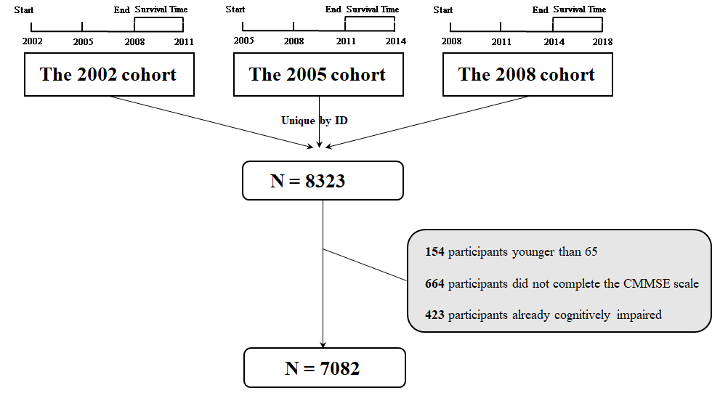

**Figure S1** Flow chart of the study population

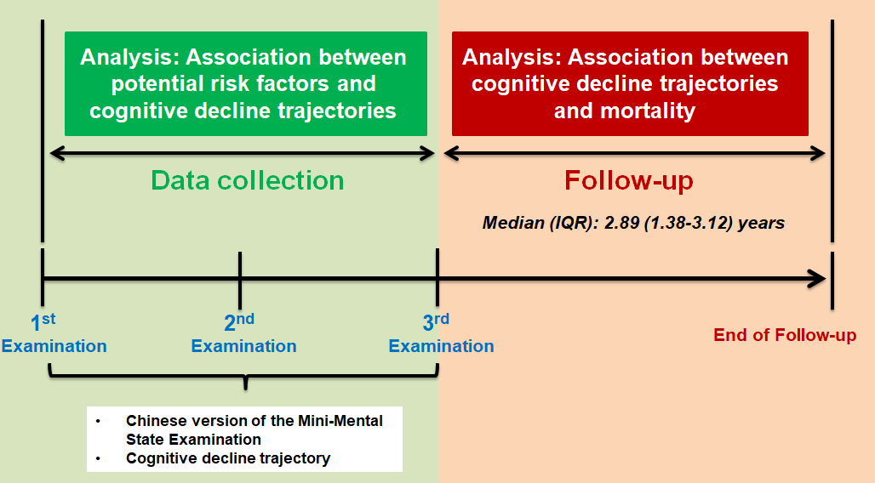

**Figure S2** Timeline of data collection