Supplementary Material
Supplementary Table 1. Item-response probabilities in models with two latent classes.
Supplementary Table 2. Components and scoring of the lifestyle behaviors.
Supplementary Table 3. Associations SES and LB scores with cognitive impairment according to sex.
Supplementary Table 4. Associations SES and LB scores with cognitive impairment according to residence.
Supplementary Table 5. Associations SES and LB scores with cognitive impairment according to with or without hypertension.
Supplementary Table 6. Associations SES and LB scores with cognitive impairment according to with or without diabetes.
Supplementary Table 7. Associations SES and LB scores with cognitive impairment according to with or without CVD.
Supplementary Table 8. Associations SES and LB scores with cognitive impairment according to with or without cancer.
Supplementary Figure 1. Flow chart of participants selection.
Supplementary Figure 2. Dose–response association between LB scores and risk of cognitive impairment.
Supplementary Table 1. Item-response probabilities in models with two latent classes.
Item | Latent class 1 | Latent class 2
Annual per-capita household income
Quartile 1 | 0.048 | 0.333
Quartile 2 | 0.053 | 0.259
Quartile 3 | 0.277 | 0.300
Quartile 4 | 0.622 | 0.300
Education
Illiterate | 0.158 | 0.607
Primary and below | 0.308 | 0.332
Junior high school and above | 0.534 | 0.060
Occupation
Farmer | 0.028 | 0.848
Non-farmer | 0.972 | 0.152
Abbreviations: SES, socioeconomic status.
We evaluated the characteristics of each latent class in each model. For the two-latent-class solution, latent class 1 was characterized by high income, junior high school and above, and non-farmer, which could be defined as “high SES”; latent class 2 was characterized by low income, illiterate, and farmer, which could be defined as “low SES”.
Supplementary Table 2. Components and scoring of the lifestyle behaviors.
Lifestyle behavior | 0 point | 1 point
Smoking | Current smoking | Current not smoking
Alcohol consumption | Current alcohol consumption | Current no alcohol consumption
Physical activity | Not regularly at present | Regularly at present
Sleep | <7 and >9 hours per day | >=7 and <= 9 hours per day
Social participantion | All five types of activities (Tai Ji, Square dance, Visit and interact with friends, Play cards or mah-jong, and Social activities (organized)) with reponses of “not every week, but once a month”, “not every month, but sometimes,” or “never”. | Any one of the five types of activities (Tai Ji, Square dance, Visit and interact with friends, Play cards or mah-jong, and Social activities (organized)) with reponses of “almost everyday” or “not every day, but at least once in a week”.
Diet | The dietary diversity score was below the mean value. | The dietary diversity score was at or above the mean value.
Body mass index | <18.5 and >24.9 | >=18.5 and <=24.9

Supplementary Table 3. Associations SES and LB scores with cognitive impairment according to sex.
Subgroup | Participants | Events | OR (95%CI)
Men
SES
High SES | 1675 | 143 | 1
Low SES | 2765 | 384 | 1.535(1.123-2.099)
LB scores
0-2 | 1082 | 224 | 1
3-4 | 2449 | 283 | 0.528(0.416-0.670)
5-6 | 909 | 20 | 0.175(0.105-0.291)
Women
SES
High SES | 1247 | 165 | 1
Low SES | 4429 | 1180 | 1.339(1.031-1.739)
LB scores
0-2 | 1144 | 478 | 1
3-4 | 3362 | 816 | 0.637(0.537-0.757)
5-6 | 1170 | 51 | 0.209(0.149-0.293)
Abbreviations: CI, confidence interval; LB, lifestyle behavior; OR, Odds ratio; SES, socioeconomic status.

Supplementary Table 4. Associations SES and LB scores with cognitive impairment according to residence.
Subgroup | Participants | Events | OR (95%CI)
Urban
SES
High SES | 1999 | 220 | 1
Low SES | 584 | 155 | 1.424(1.062-1.910)
LB scores
0-2 | 288 | 67 | 1
3-4 | 1442 | 289 | 0.964(0.672-1.385)
5-6 | 853 | 19 | 0.250(0.139-0.450)
Rural | 7533
SES
High SES | 923 | 88 | 1
Low SES | 6610 | 1409 | 1.454(1.101-1.920)
LB scores
0-2 | 1938 | 635 | 1
3-4 | 4369 | 810 | 0.547(0.470-0.637)
5-6 | 1226 | 52 | 0.201(0.145-0.278)
Abbreviations: CI, confidence interval; LB, lifestyle behavior; OR, Odds ratio; SES, socioeconomic status

Supplementary Table 5. Associations SES and LB scores with cognitive impairment according to with or without hypertension.
Subgroup | Participants | Events | OR (95%CI)
Hypertension
SES
High SES | 1578 | 127 | 1
Low SES | 2661 | 428 | 1.236(0.894-1.709)
LB scores
0-2 | 801 | 192 | 1
3-4 | 2424 | 343 | 0.666(0.523-0.848)
5-6 | 1014 | 20 | 0.156(0.094-0.261)
Non-hypertension | 5877
SES
High SES | 1344 | 181 | 1
Low SES | 4533 | 1136 | 1.430(1.110-1.842)
LB scores
0-2 | 1425 | 510 | 1
3-4 | 3387 | 756 | 0.572(0.482-0.679)
5-6 | 1065 | 51 | 0.227(0.161-0.319)
Abbreviations: CI, confidence interval; LB, lifestyle behavior; OR, Odds ratio; SES, socioeconomic status

Supplementary Table 6. Associations SES and LB scores with cognitive impairment according to with or without diabetes.
Subgroup | Participants | Events | OR (95%CI)
Diabetes
SES
High SES | 557 | 44 | 1
Low SES | 484 | 62 | 1.054(0.524-2.124)
LB scores
0-2 | 146 | 31 | 1
3-4 | 578 | 67 | 0.543(0.303-0.973)
5-6 | 317 | 8 | 0.235(0.094-0.589)
Non-diabetes | 9075
SES
High SES | 2365 | 264 | 1
Low SES | 6710 | 1502 | 1.438(1.168-1.770)
LB scores
0-2 | 2080 | 671 | 1
3-4 | 5233 | 1032 | 0.606(0.525-0.699)
5-6 | 1762 | 63 | 0.193(0.144-0.260)
Abbreviations: CI, confidence interval; LB, lifestyle behavior; OR, Odds ratio; SES, socioeconomic status

Supplementary Table 7. Associations SES and LB scores with cognitive impairment according to with or without CVD.
Subgroup | Participants | Events | OR (95%CI)
CVD
SES
High SES | 1049 | 120 | 1
Low SES | 1396 | 268 | 1.468(1.013-2.126)
LB scores
0-2 | 462 | 128 | 1
3-4 | 1409 | 241 | 0.685(0.505-0.928)
5-6 | 574 | 19 | 0.237(0.136-0.413)
Non-CVD | 7671
SES
High SES | 1873 | 188 | 1
Low SES | 5798 | 1296 | 1.365(1.077-1.731)
LB scores
0-2 | 1764 | 574 | 1
3-4 | 4402 | 858 | 0.587(0.502-0.687)
5-6 | 1505 | 52 | 0.193(0.139-0.268)
Abbreviations: CVD, cardiovascular disease; CI, confidence interval; LB, lifestyle behavior; OR, Odds ratio; SES, socioeconomic status

Supplementary Table 8. Associations SES and LB scores with cognitive impairment according to with or without cancer.
Subgroup | Participants | Events | OR (95%CI)
Cancer
SES
High SES | 83 | 10 | 1
Low SES | 75 | 15 | 1.625(0.416-6.349)
LB scores
0-2 | 25 | 9 | 1
3-4 | 89 | 15 | 0.298(0.085-1.038)
5-6 | 44 | 1 | 0.051(0.005-0.537)
Non-Cancer
SES
High SES | 2839 | 298 | 1
Low SES | 7119 | 1549 | 1.385(1.133-1.692)
LB scores
0-2 | 2201 | 693 | 1
3-4 | 5722 | 1084 | 0.607(0.527-0.698)
5-6 | 2035 | 70 | 0.203(0.153-0.270)
Abbreviations: CI, confidence interval; LB, lifestyle behavior; OR, Odds ratio; SES, socioeconomic status.

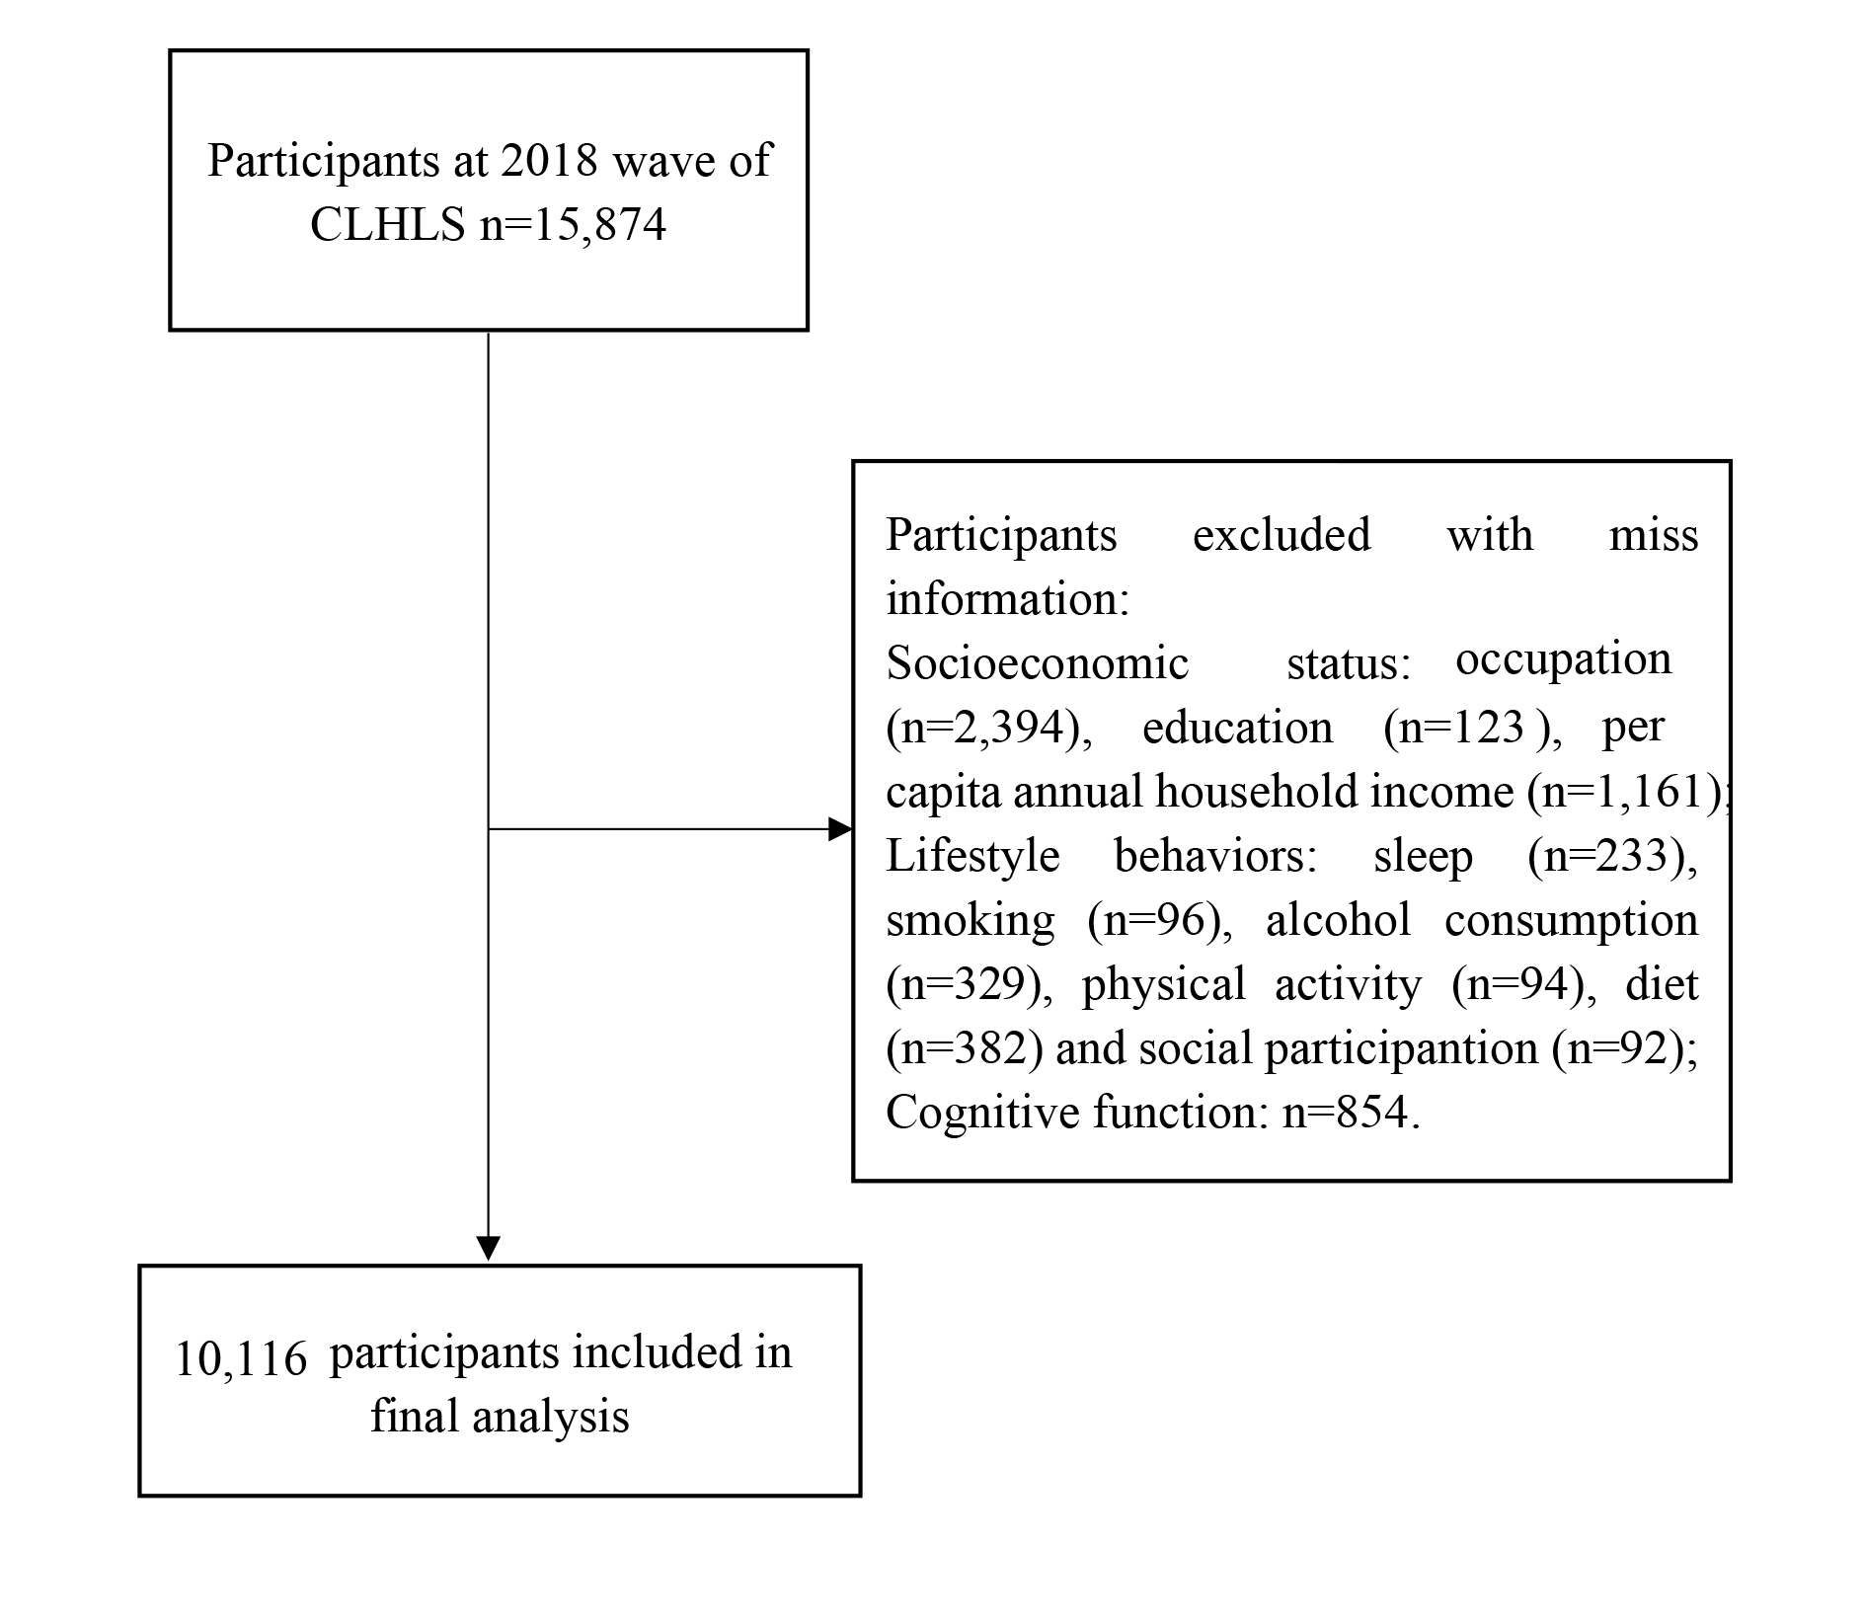
Supplementary Figure 1. Flow chart of participants selection. CLHLS, Chinese Longitudinal Healthy Longevity Survey
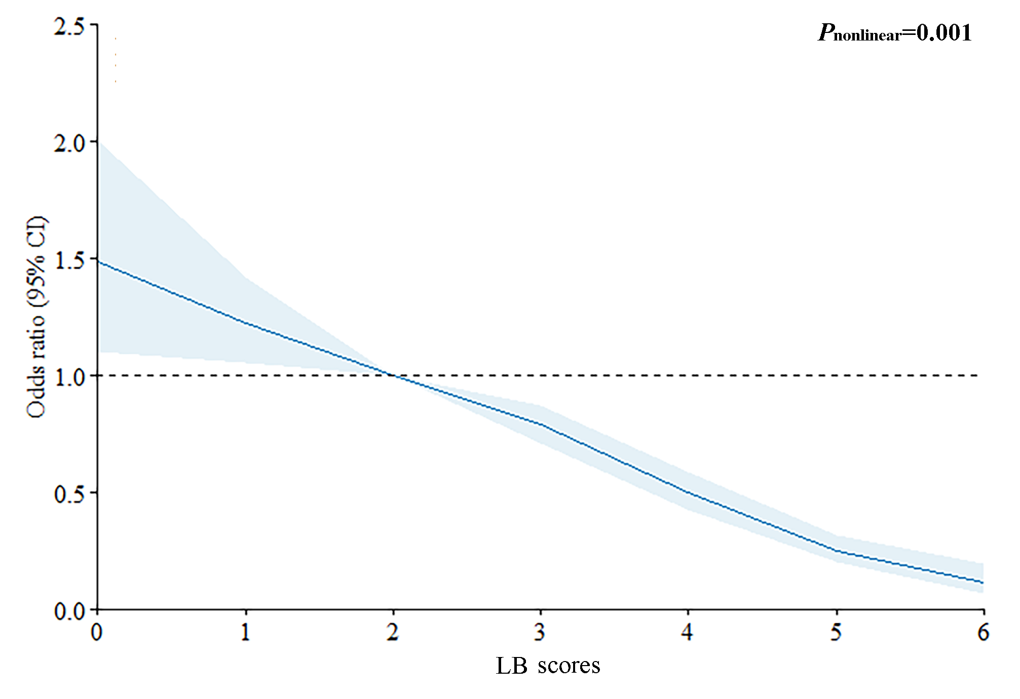
Supplementary Figure 2. Dose–response association between LB scores and risk of cognitive impairment. CI, confidence interval; LB, lifestyle behavior

