Supplementary materials
eTable 1. Multiple linear regression analysis for the interaction between Aβ deposition and LDL-C for tau deposition controlling statin use as an additional covariate
 |  |  | Coefficients |  |  | t | P value
 |  |  | B | SE | β
Dependent variable: Tau depositionª
Global Aβ deposition |  |  | 0.149 | 0.378 | 0.084 | 0.393 | 0.695
LDL-C |  |  | -0.009 | 0.005 | -0.363 | -1.613 | 0.109
Global Aβ deposition x LDL-C |  |  | 0.006 | 0.003 | 0.589 | 1.988 | 0.049
Notes: Multiple linear regression model included age, gender, education, APOE ε4 positivity, VRS_{noDLP}, and statin use as covariates.
ª F for the model=7.776; adjusted R²=0.316.
Abbreviations: Aβ, beta-amyloid; LDL-C, low density lipoprotein cholesterol; APOE, apolipoprotein; VRS_{noDLP}, vascular risk score reflecting vascular risk burden other than dyslipidemia.

eTable 2. Multiple linear regression analysis for the interaction between Aβ deposition and LDL-C for tau deposition with time gap as an additional covariate
 |  |  | Coefficients |  |  | t | P value
 |  |  | B | SE | β
Dependent variable: Tau depositionª
Global Aβ deposition |  |  | 0.141 | 0.381 | 0.079 | 0.369 | 0.713
LDL-C |  |  | -0.009 | 0.005 | -0.369 | -1.621 | 0.108
Global Aβ deposition x LDL-C |  |  | 0.006 | 0.003 | 0.595 | 1.995 | 0.048
Notes: Multiple linear regression model included age, gender, education, APOE ε4 positivity, VRS_{noDLP,} and time gap as covariates.
ª F for the model=7.781; adjusted R²=0.316.
Abbreviations: Aβ, beta-amyloid; LDL-C, low density lipoprotein cholesterol; APOE, apolipoprotein; VRS_{noDLP}, vascular risk score reflecting vascular risk burden other than dyslipidemia.

eTable 3. Multiple linear regression analysis for the interaction between Aβ deposition and other lipids for tau deposition
 |  |  |  | Coefficients |  |  | t | P value
 |  |  |  | B | SE | β
Dependent variable: Tau retention
TC |  | Global Aβ retention |  | 0.035 | 0.562 | 0.020 | 0.063 | 0.950
 |  | TC |  | -0.006 | 0.005 | -0.272 | -10188 | 0.237
 |  | Global Aβ retention x TCª |  | 0.005 | 0.003 | 0.568 | 1.491 | 0.139
HDL-C |  | Global Aβ retention |  | 0.599 | 0.528 | 0.337 | 1.133 | 0.259
 |  | HDL-cholesterol |  | -0.005 | 0.015 | -0.084 | -0.349 | 0.727
 |  | Global Aβ retention x HDL-C^{b} |  | 0.005 | 0.010 | 0.185 | 0.478 | 0.633
TG |  | Global Aβ retention |  | 1.291 | 0.319 | 0.726 | 4.042 | 0.000
 |  | TG |  | 0.005 | 0.003 | 0.379 | 1.421 | 0.158
 |  | Global Aβ retention x TG^{c} |  | -0.004 | 0.002 | -0.501 | -1.605 | 0.111
Notes: Multiple linear regression model included age, gender, education, APOE ε4 positivity, and VRS_{noDLP} as covariates.
ª F for the model=8.445; adjusted R²=0.311.
^{b} F for the model=8.020; adjusted R²=0.341
^{c} F for the model=8.476; adjusted R²=0.312
Abbreviations: Aβ, beta-amyloid; TC, total cholesterol, HDL-C, high density lipoprotein cholesterol; TG, triglyceride; APOE, apolipoprotein; VRS_{noDLP}, vascular risk score reflecting vascular risk burden other than dyslipidemia.

eFigure 1. Multiple linear regression plots showing moderating effects of LDL-C on the relationships between Aβ and tau deposition.

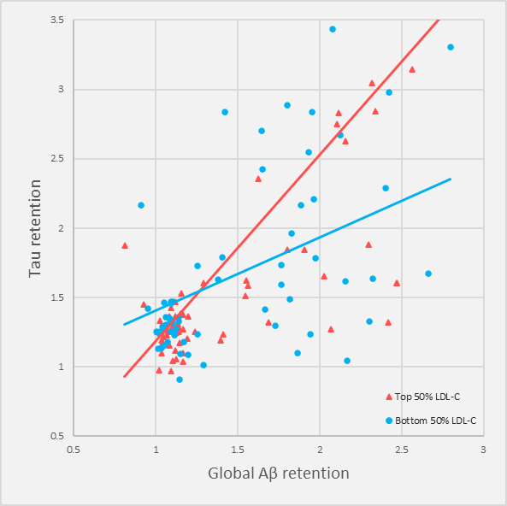

Note: For the purpose of demonstration, participants were divided top 50% LDL-C and the bottom 50% LDL-C subgroups. Multiple linear regression model included Aβ, LDL-cholesterol subgroup, and their interaction term as independent variables; tau retention as dependent variable; and age, gender, education, APOE ε4 positivity, and VRS_{noDLP} as covariates. Statistical significance was observed with the interaction term between Aβ deposition and LDL-C (p < 0.05), as detailed in the manuscript.
Abbreviations: Aβ, beta-amyloid; APOE, apolipoprotein; LDL-C, low density lipoprotein cholesterol; VRS_{noDLP,} vascular risk score reflecting vascular risk burden other than dyslipidemia.

