**Supplementary Figure 1. Leave-one-out sensitivity analysis for** **gut microbiome on AD (Dutch cohort).** A. Class *Betaproteobacteria*. B. Order *Burkholderiales*. C. Species *Clostridium asparagiforme*. D. Family *Coriobacteriaceae*. E. Order *Coriobacteriales*. F. Species *Veillonella unclassified*. G. Species *Bifidobacterium bifidum*. H. Family *Bacteroidaceae*. I. Family *Sutterellaceae*. J. Class *Bacilli*.

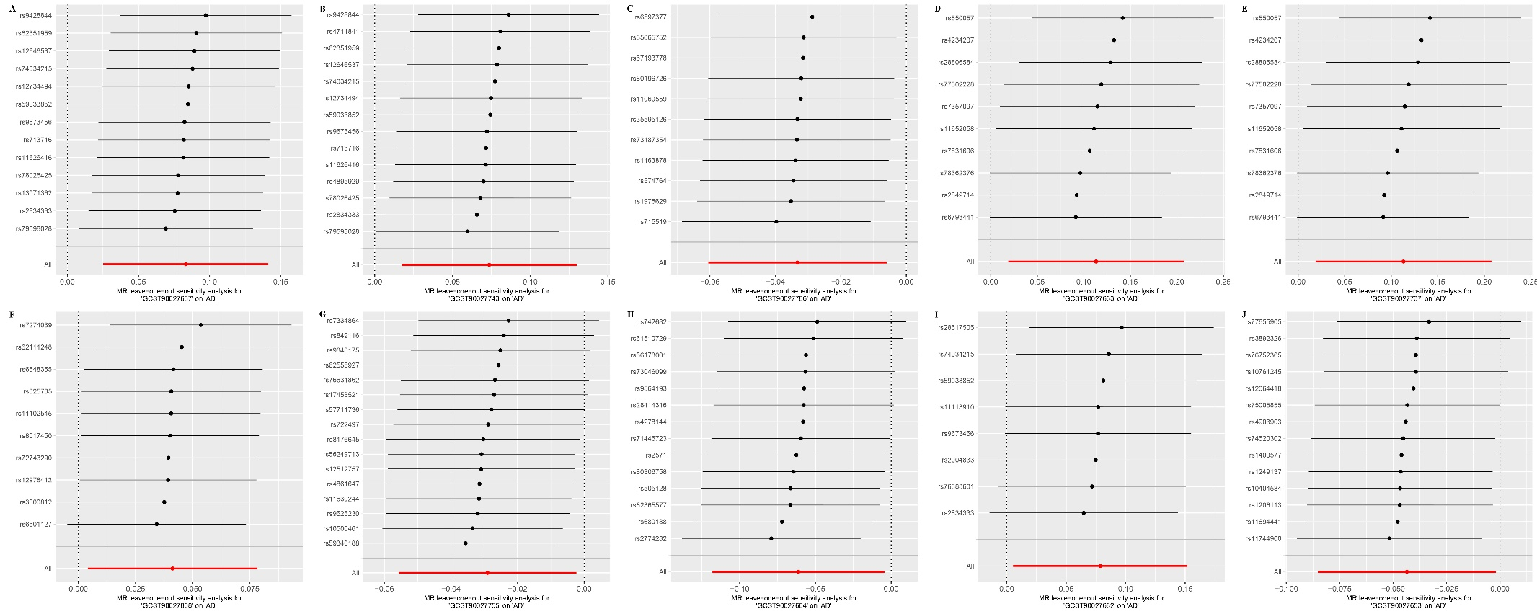

**Supplementary Figure 2. Leave-one-out sensitivity analysis for** **gut microbiome on AD (MiBioGen cohort).** A. Class Mollicutes. B. Phylum *Tenericutes*. C. Class *Actinobacteria*. D. Class *Negativicutes*. E. Order *Selenomonadales*. F. Class *Clostridia*. G. Family *Pasteurellaceae*. H. Genus *Butyrivibrio*. I. Genus *Ruminiclostridium9*. J. Order *Pasteurellales*.

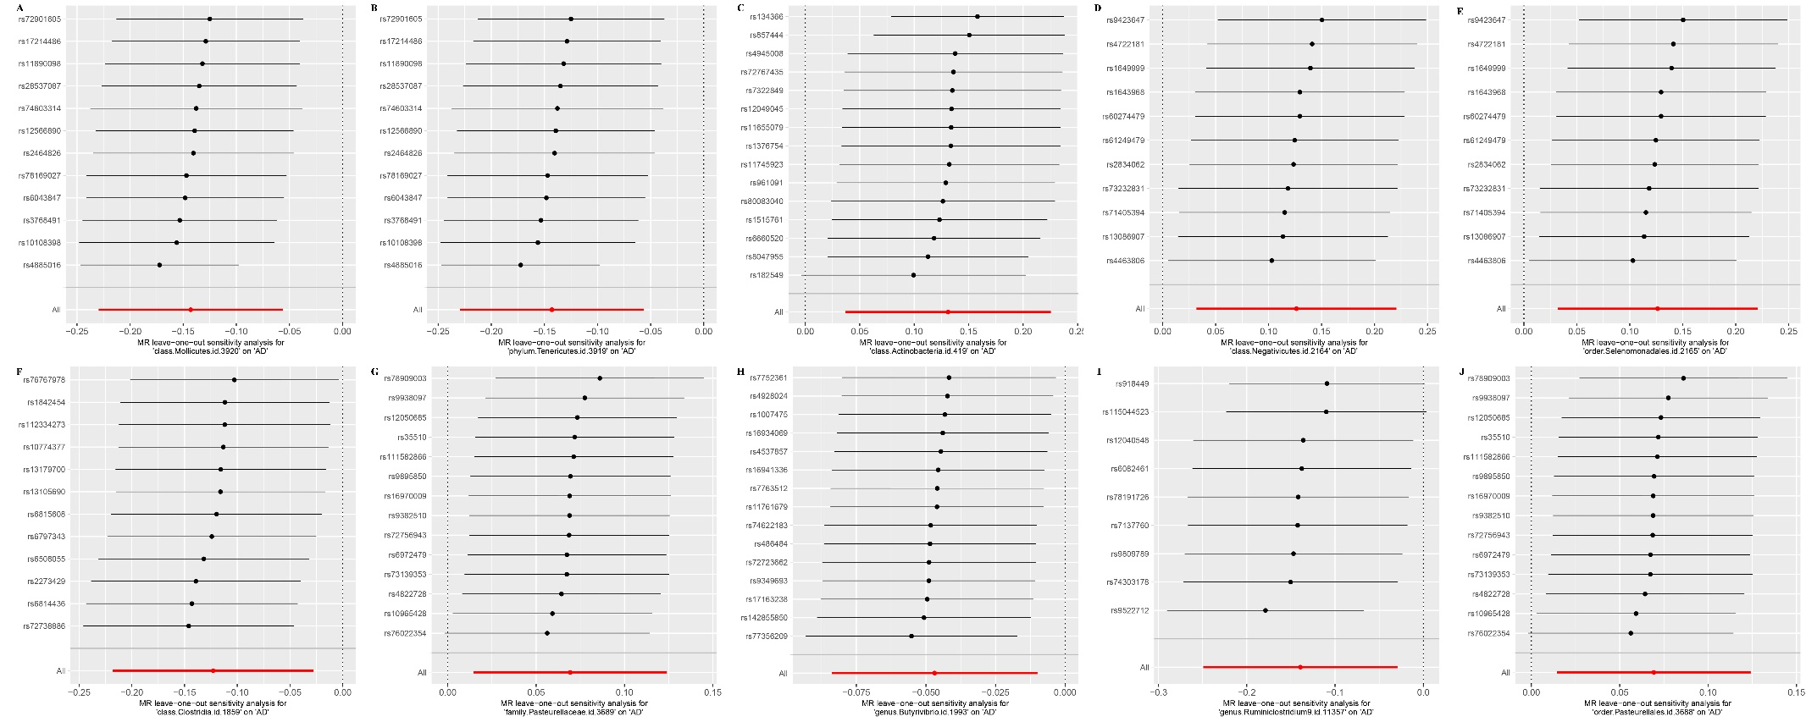

**Supplementary Figure 3. Leave-one-out sensitivity analysis for gut microbiome on AD (MiBioGen cohort).** A. Order *Clostridiales*. B. Family *Lactobacillaceae*. C. Genus *Intestinimona*. D. Genus *Clostridiuminnocuumgroup*. E. Genus *Eggerthella*. F. Genus *LachnospiraceaeUCG004*. G. Genus *Anaerotruncus*. H. Family *Bacteroidaceae*. I. Genus *Bacteroides*.

