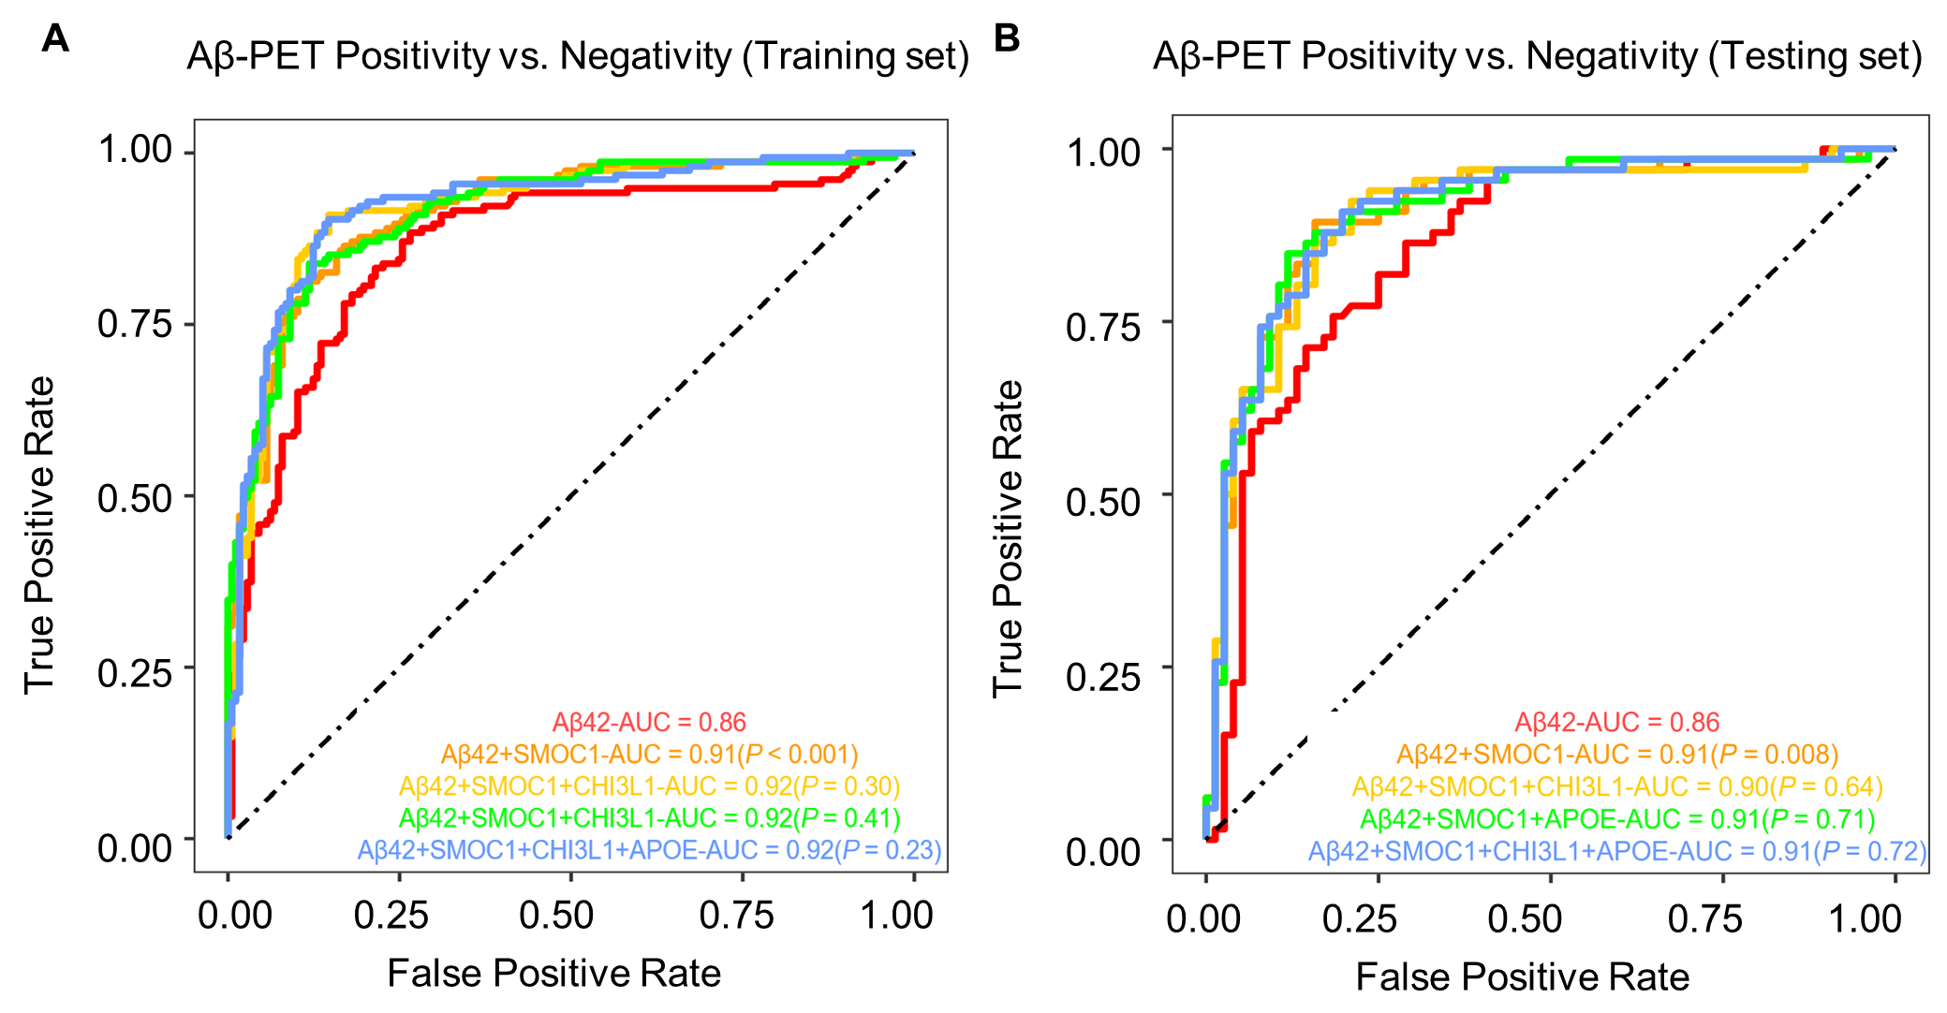

**Supplementary Figure 1** Predictive Performance of Aβ42 and the Integration of Aβ42 with Different Hub Protein Combinations in Aβ-PET Positivity Incident

**(A and B)** ROC analysis was conducted to evaluate the predictive performance of Aβ42 alone and its combination with different hub proteins for Aβ-PET positivity incident in the training and testing sets. The *P*-value associated with Aβ42 + SMOC1 indicated the significance of the comparison using DeLong’s test between the AUCs of Aβ42 alone and the combined Aβ42 and SMOC1. The *P*-values for Aβ42 + SMOC1 + CHI3L1, Aβ42 + SMOC1 + APOE, and Aβ42 + SMOC1 + CHI3L1 + APOE reflected the significance of comparing the AUCs of these combinations with the AUC of Aβ42 + SMOC1.

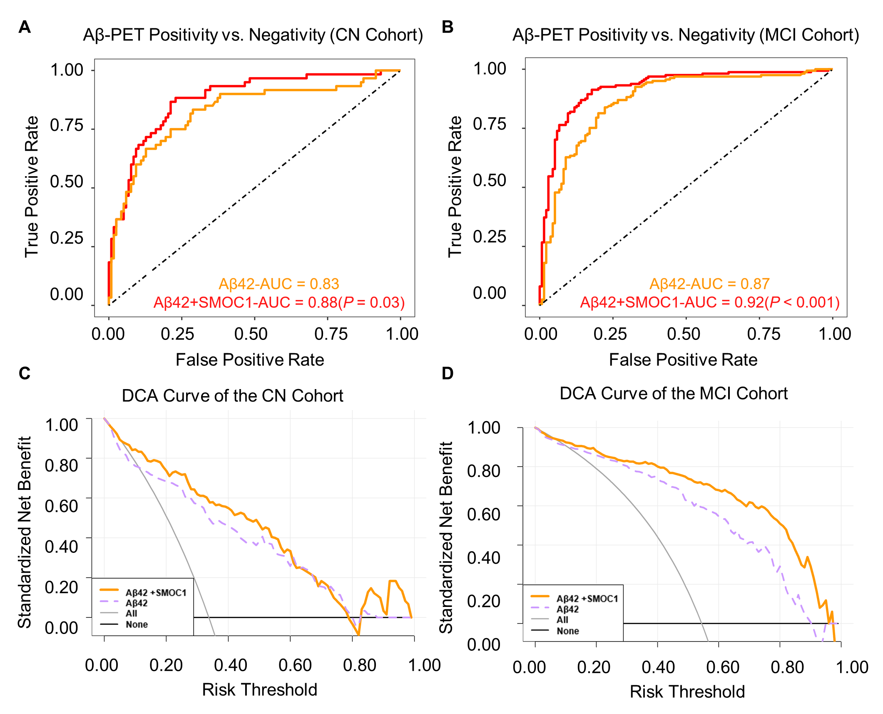

**Supplementary Figure 2** Predictive Performance Comparison Between Aβ42 and the Combination of Aβ42 with SMOC1 in Aβ-PET Positivity Incident after Stratifying the Whole Cohort into CN and MCI Subgroups

**(A and B)** ROC analysis of Aβ42 and the combination of Aβ42 with SMOC1 for predicting Aβ-PET positivity incident within the CN and MCI cohorts. The discriminative abilities of the combined protein profile and Aβ42 were compared directly using DeLong’s test. **(C and D)** DCA curves compared the standardized net benefit betweenAβ42 and the combination of Aβ42 with SMOC1 for predicting Aβ-PET positivity incident within the CN and MCI cohorts.